MWMF PROJECT REPORT  
Simple Portfolio Page made with HTML, CSS, JS and Bootstrap and hosted on localhost with Node.js

Done by – Aritra Chatterjee, CSE4DTE, 2K19CSUN3004

Submitted to – Mr. Ankur Aggarwal

Project summary:

This is a simple project made using a few different web technologies for the purpose of making a short but effective self-portfolio page which includes an interactive navigation bar which will grow and shrink in size as the page is scrolled from top to bottom, changing text color and background on mouseover on the navbar elements, having a highlighted background to make note of introduction of self, a section to view the work done for the sake of note in the portfolio using Bootstrap and JavaScript to give it some additional flair in terms of viewing it separately in the page while not having the entire content on the page itself, a validated form for contacting the creator of the portfolio, and a detailed footer section having social media links, contact address of the portfolio creator, copyright info and other significant things of interest.

Apart from this, Bootstrap has been used to make dynamic and responsive web design possible and viewing on smaller screens and screen resolutions as well without breaking the page layout. The font awesome library has been used for all the different icons/social links. A simple node.js script using the express module was created to host the page and all of its elements including the html page, the CSS, JS and the images located in one directory over localhost.

The following screenshots and the code of the page, the css, the js and the node script will explain more in detail.

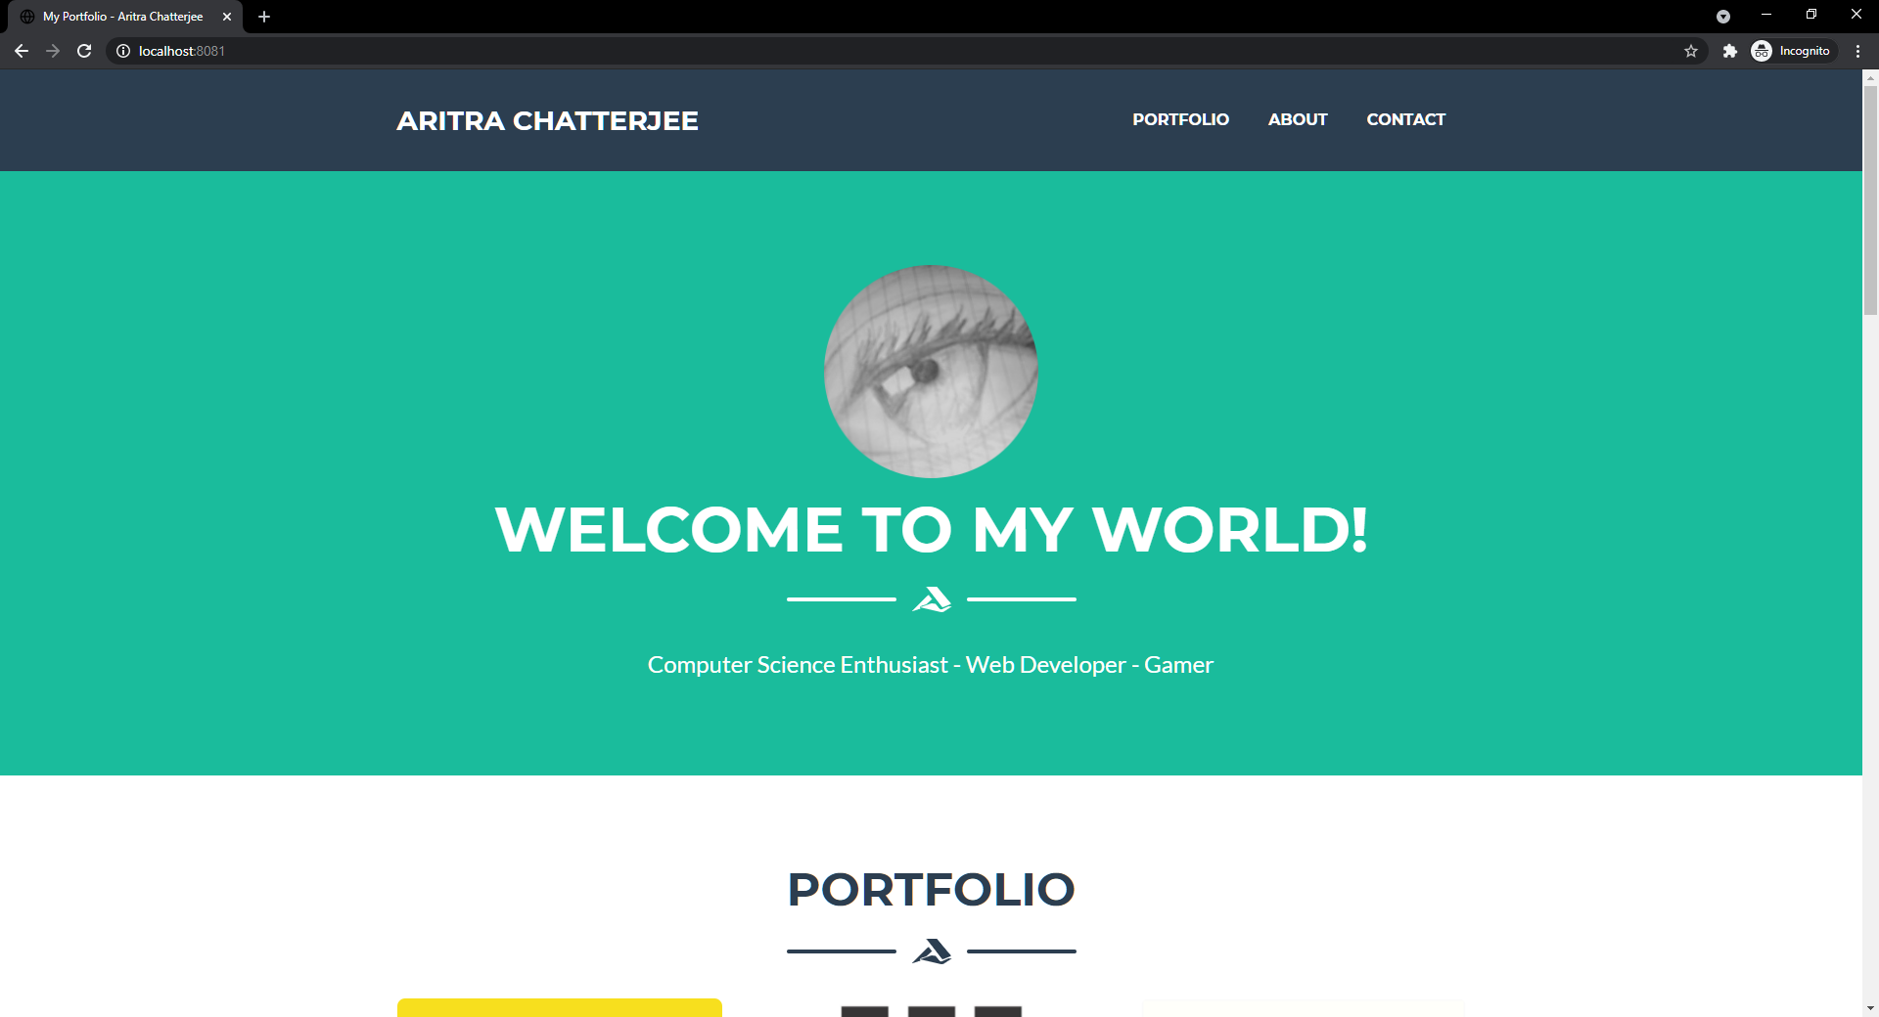

The first screenshot of the page depicts the first section of the page and the navbar with all of the different navigation links. The navbar is in its full size at the top of the page and will shrink as we scroll down or click to a navigational link for another section of the page.

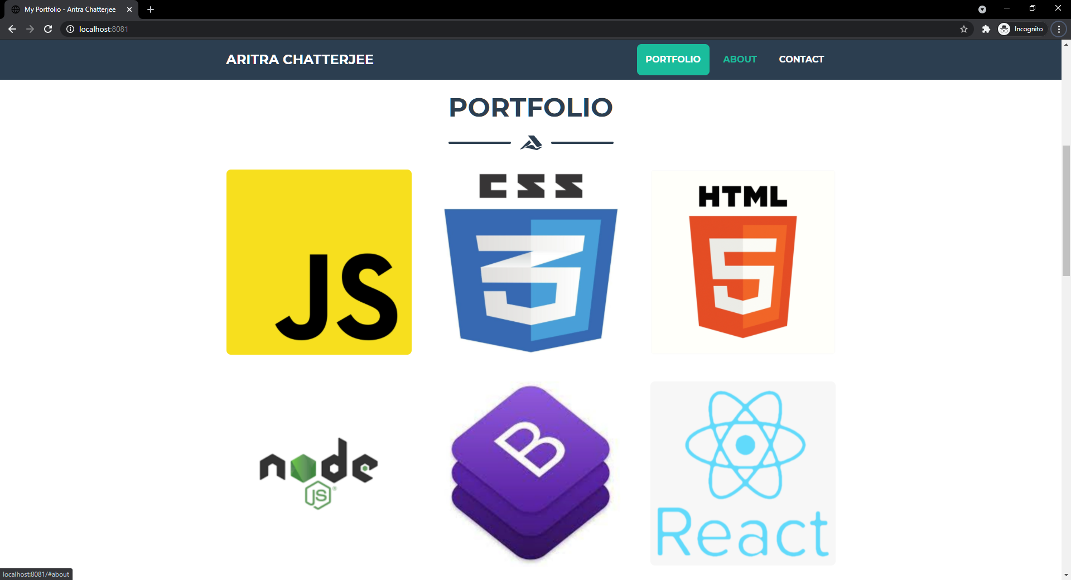

Clicking on the portfolio navigation link takes us to the portfolio section of the page which has hover-able images for different web technologies listed as a part of experience. The navbar has shrunk and the portfolio navigation link has a highlighted background beneath it. The About navigation link has been mouse overed on to signify that it changes color. The Contact navigation link is intact as it is not being focused on.

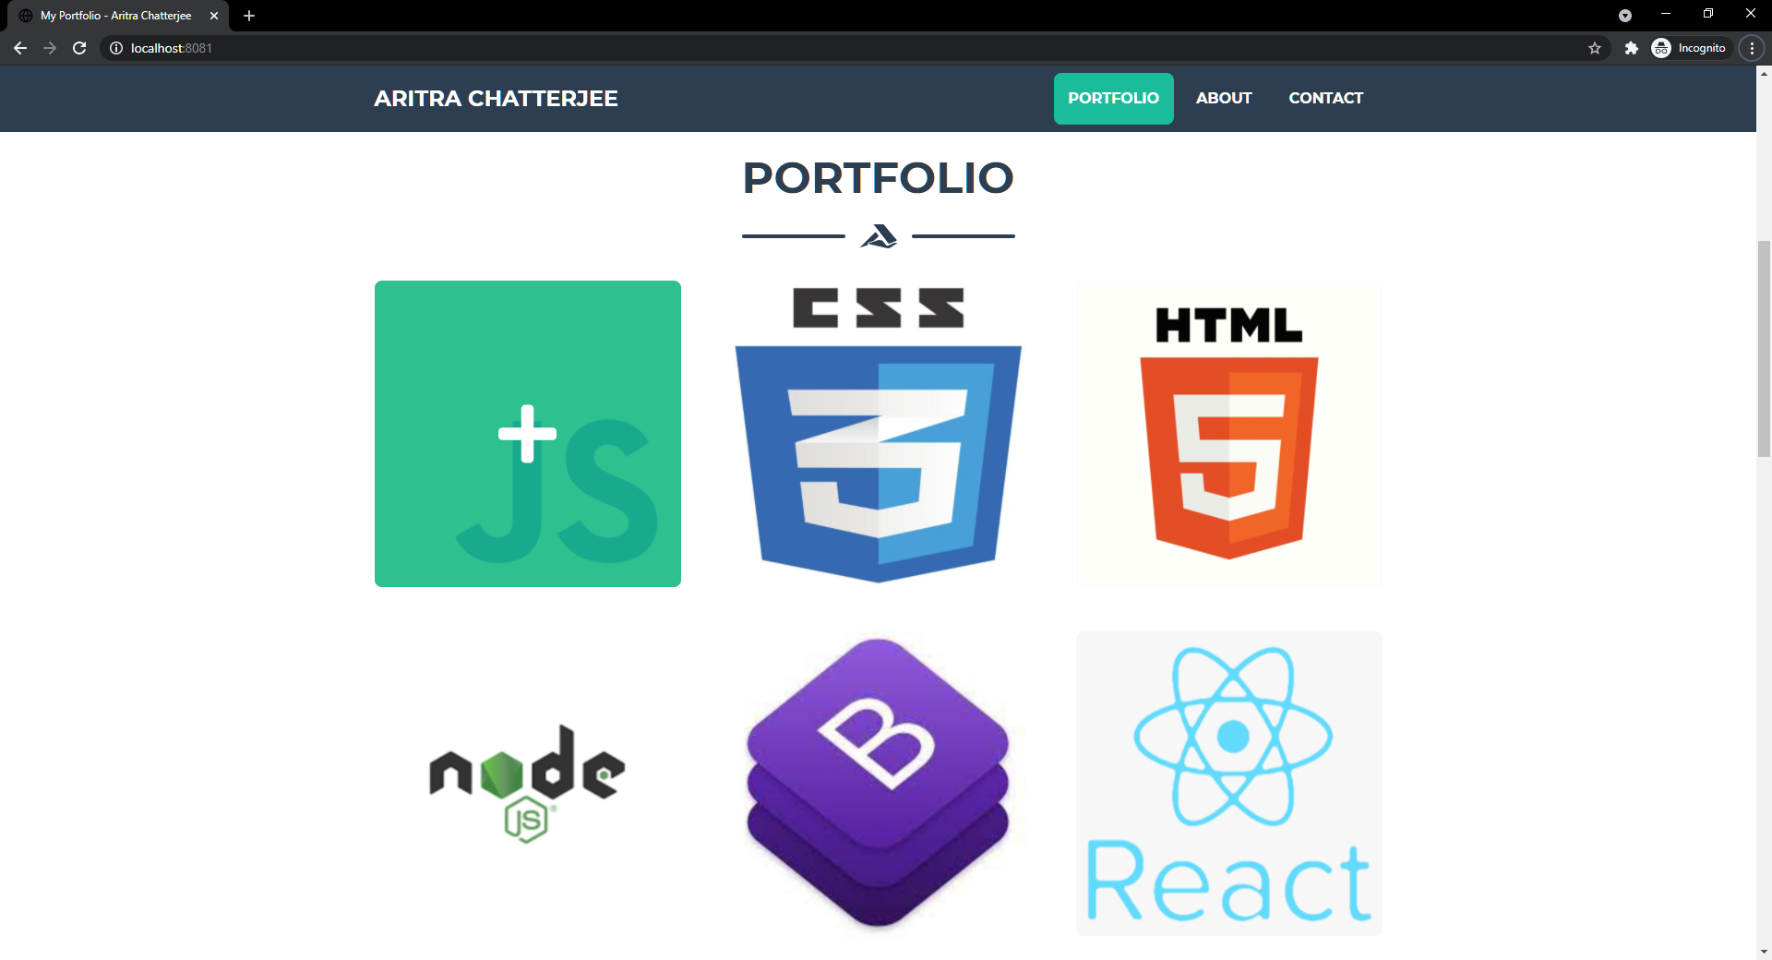

Hovering over the first image brings out a translucent overlay, clicking on which will bring up a pop-out section having the details for that particular web technology’s details relating to the portfolio creator.

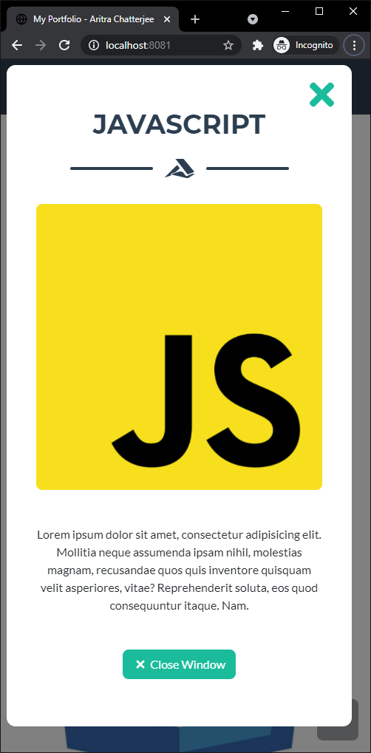

This pop-out section can be closed using the close window button or the X symbol in the top right corner.

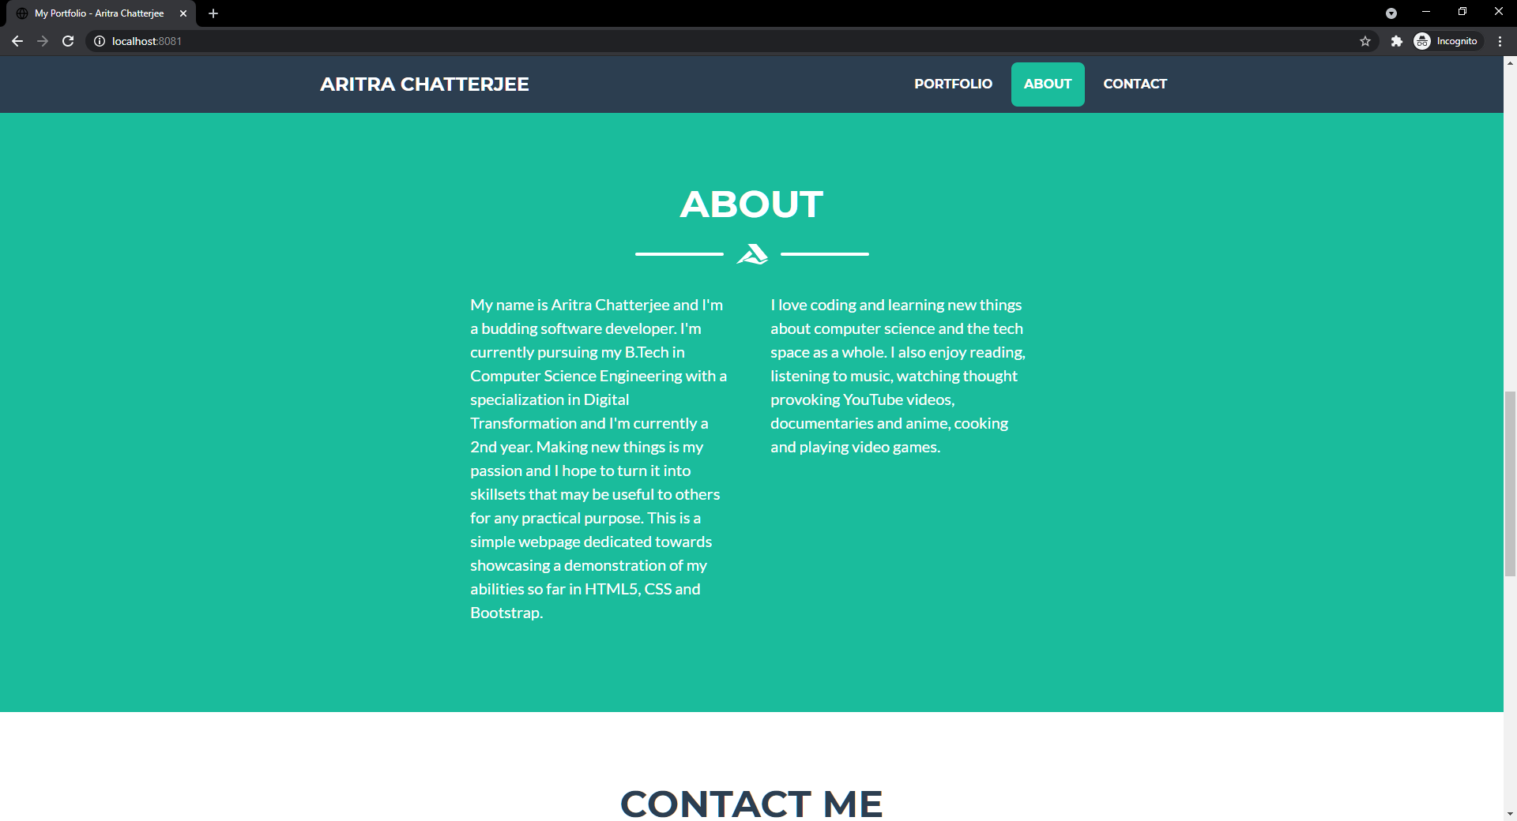

Next is a small About section which lists details about the portfolio which gives a brief overview about the portfolio creator. The about navigation link is highlighted as such.

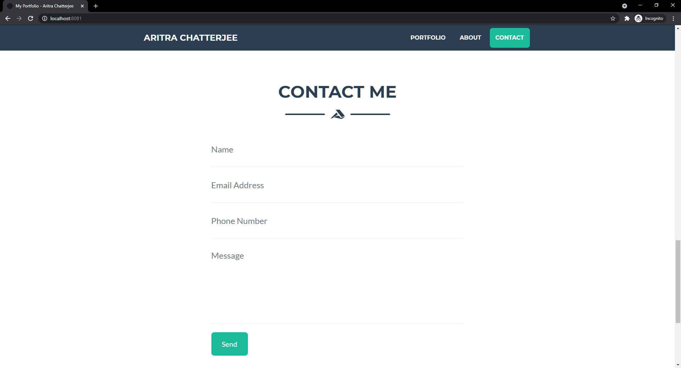

After that, the contact me section has a well-defined form (with inputs fields for different types of form data) for relevant information to be provided to be able to contact the portfolio creator for inquiries/business purposes etc. The form is validated and will display warnings if empty fields or incorrect data is entered as can be seen from the following screenshot.

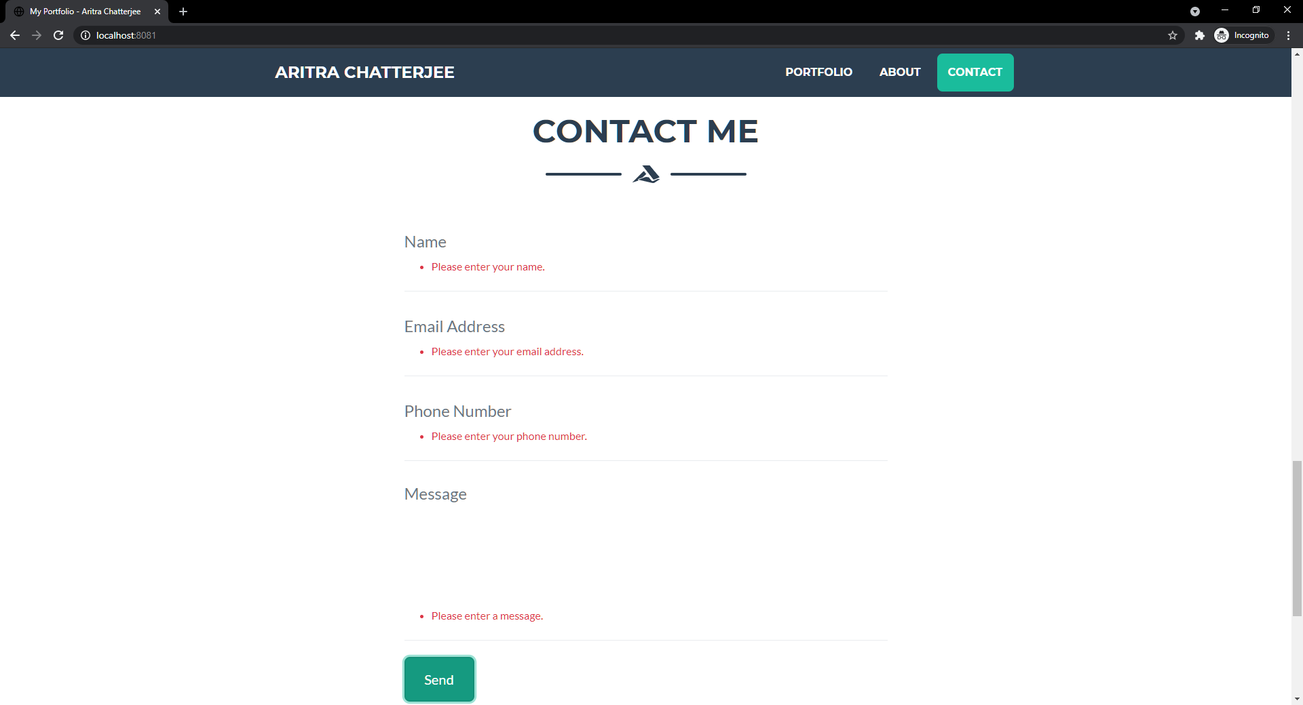

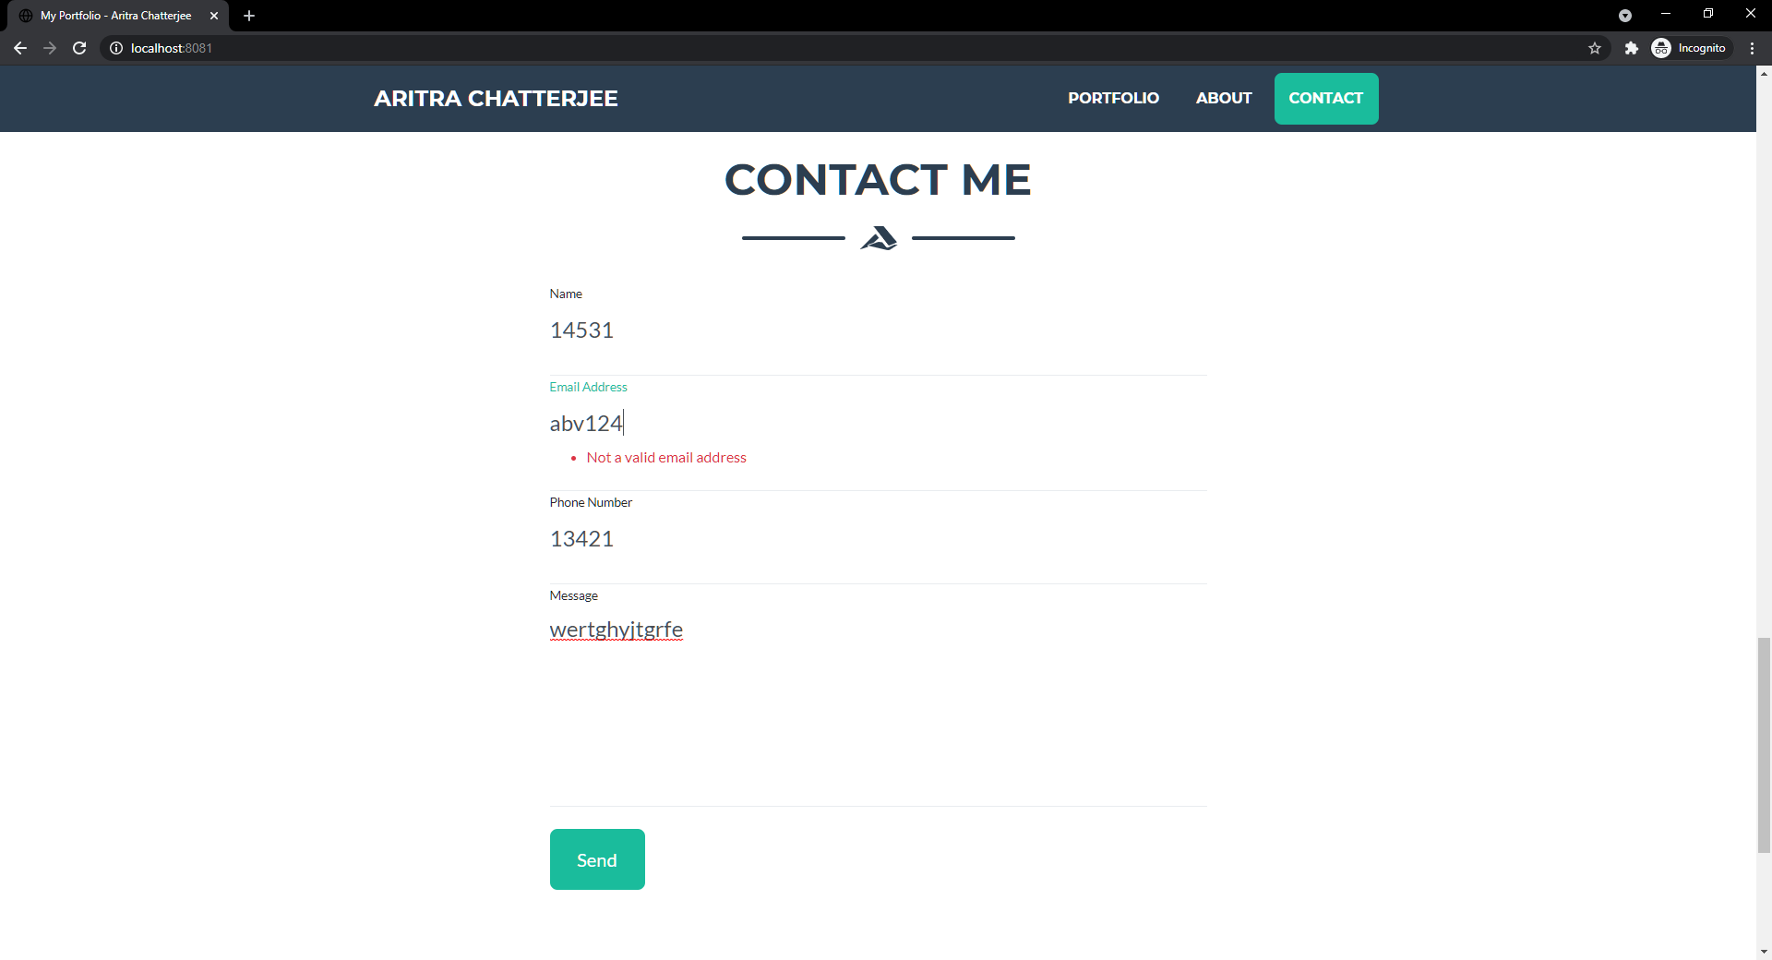

Proper e-mail format validation using regex.

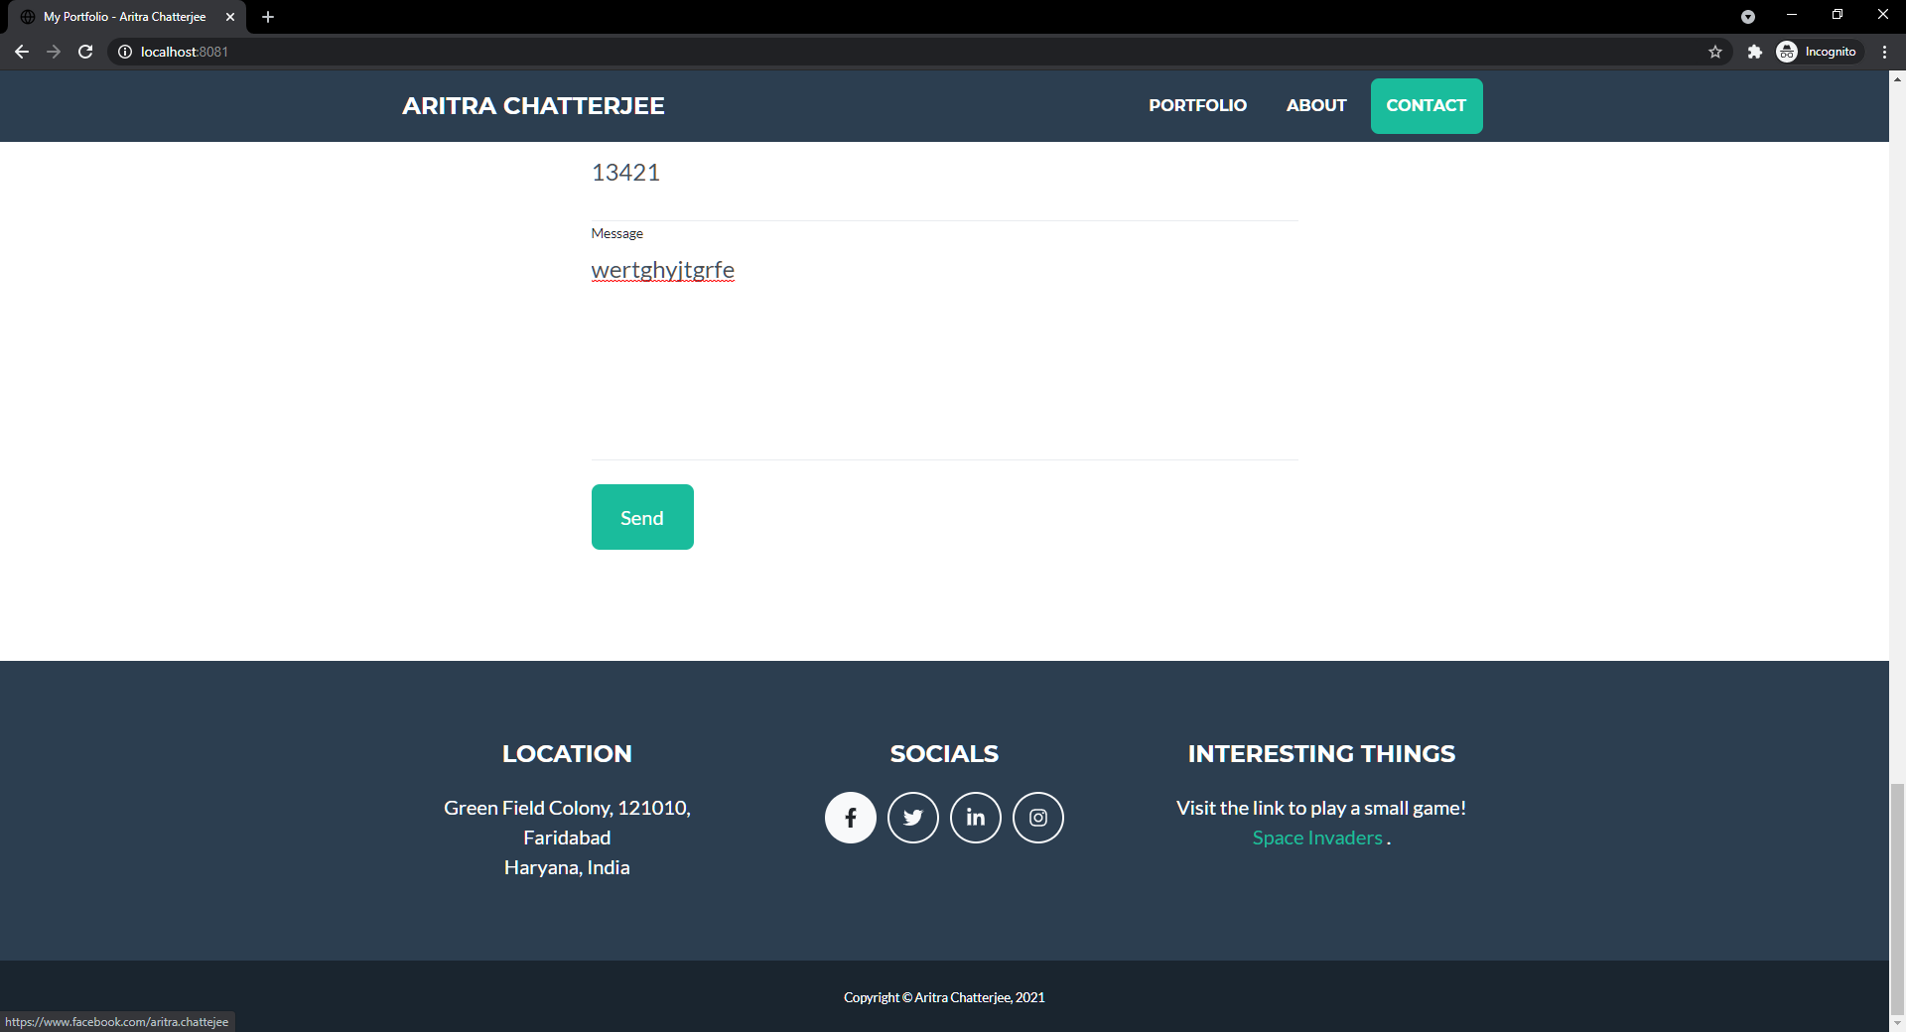

Footer information containing location, font awesome social links which take us to different social websites of the portfolio creator. Other links of interest have also been provided along with location and copyright info.

The page has been hosted on localhost port 8081 with a node.js script. The code of the entire page is given as follows:

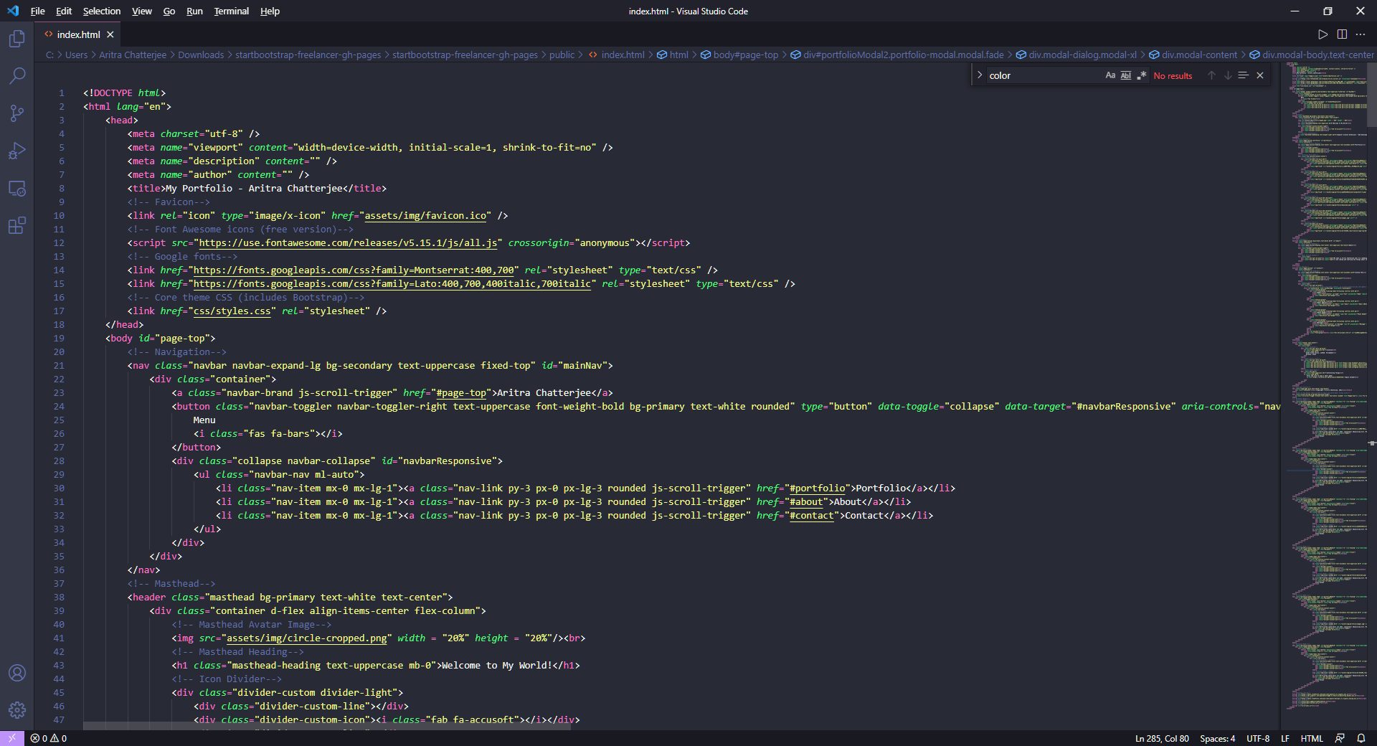

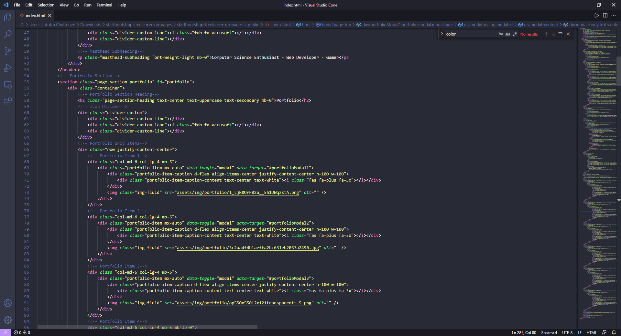

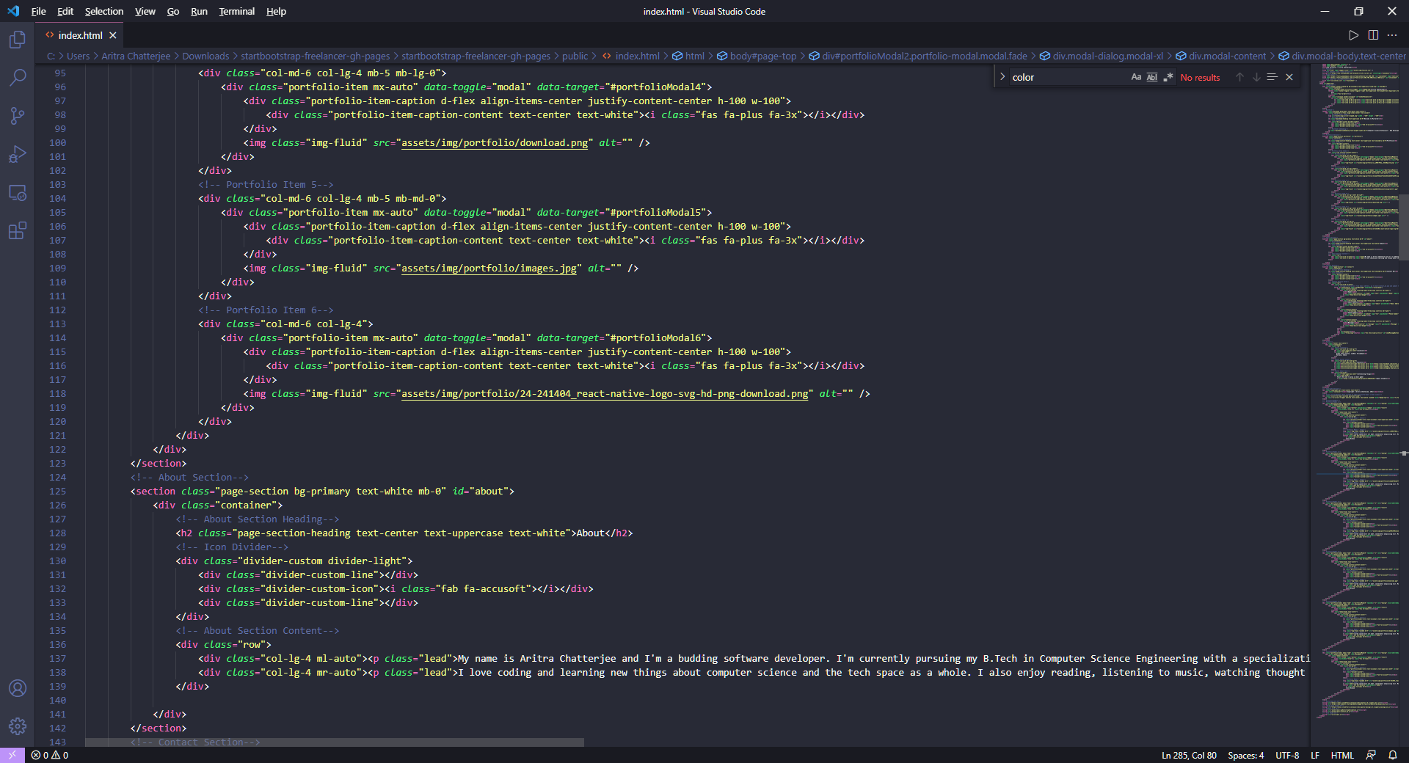

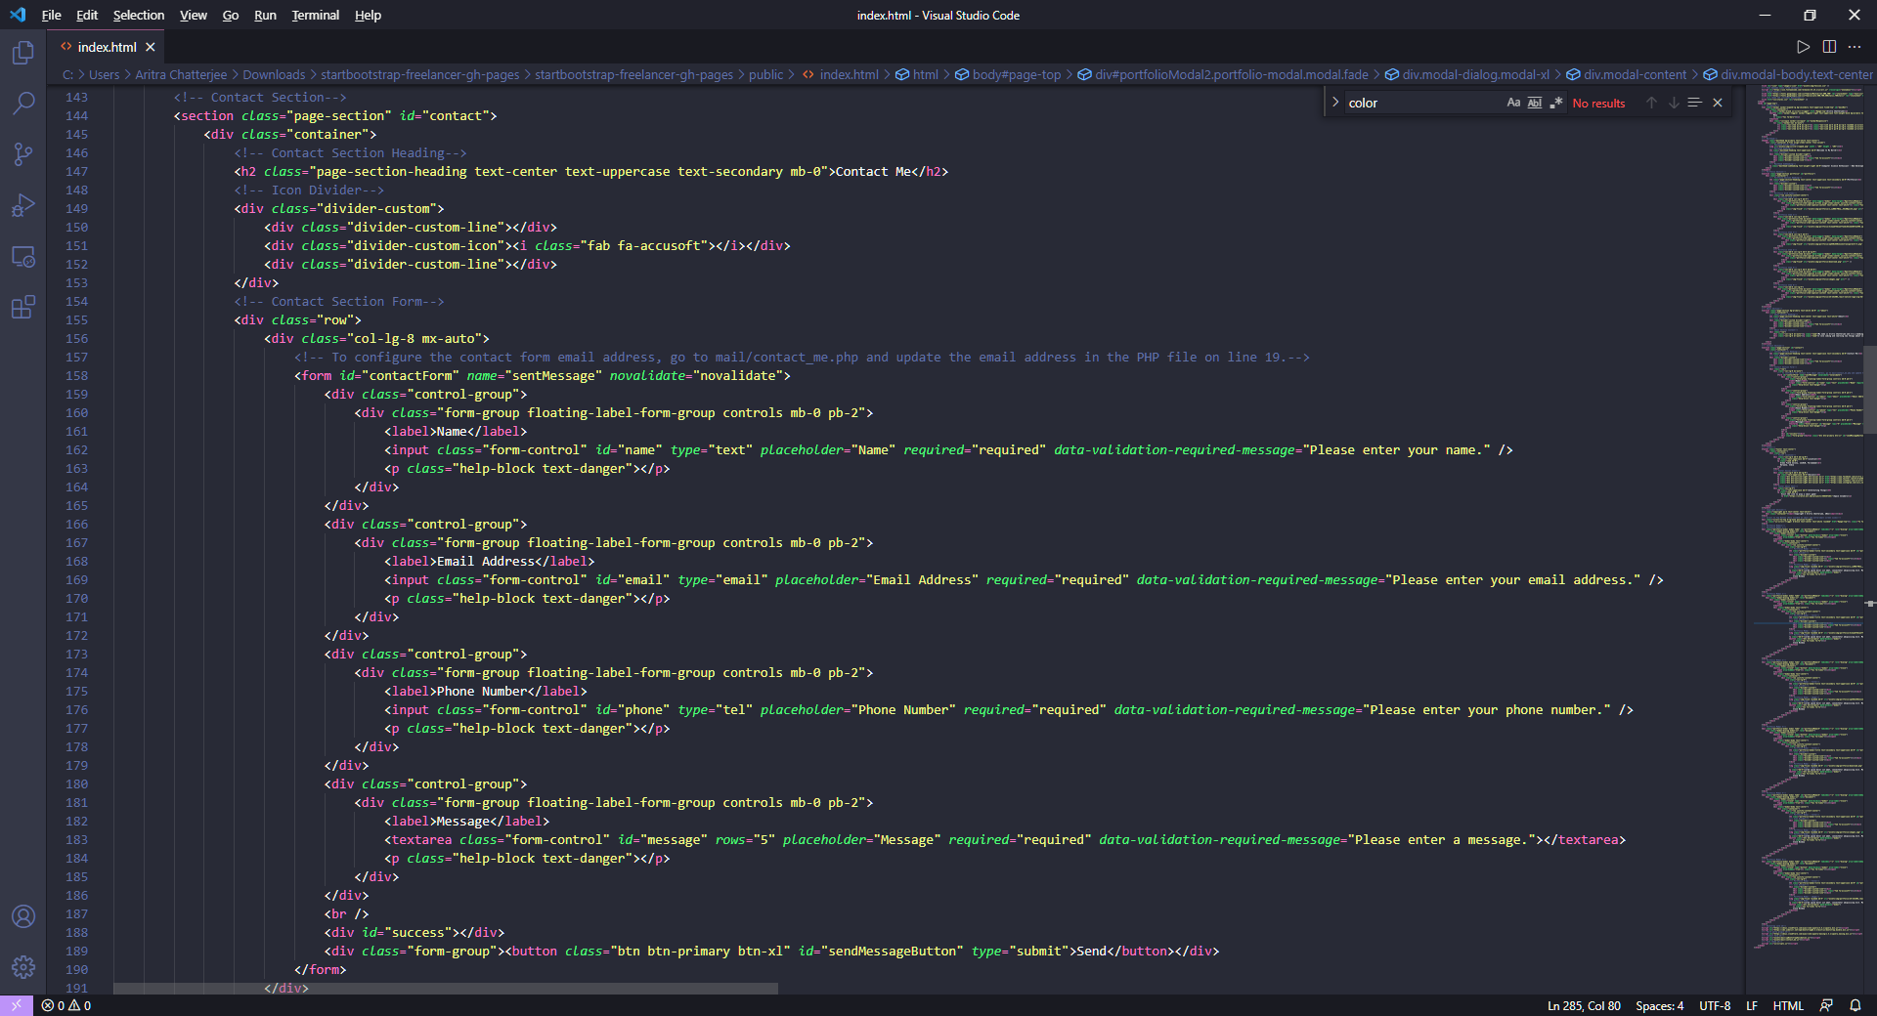

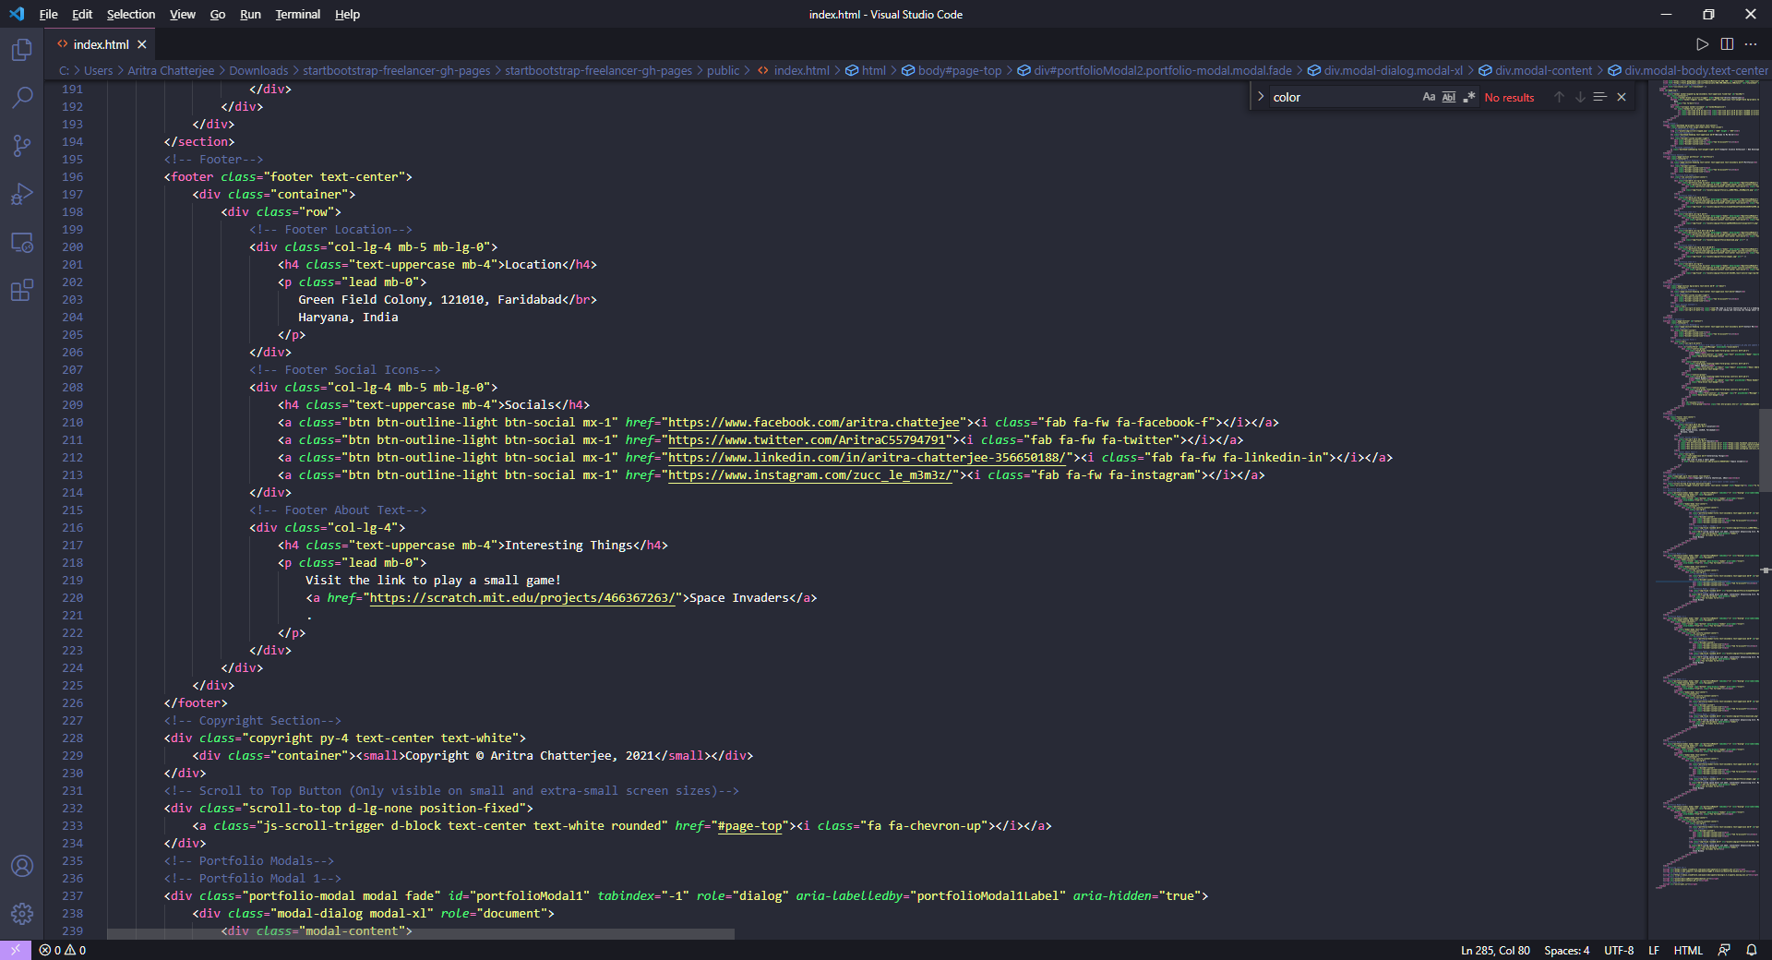

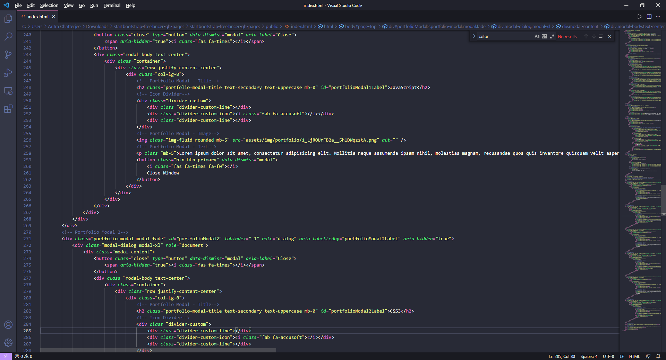

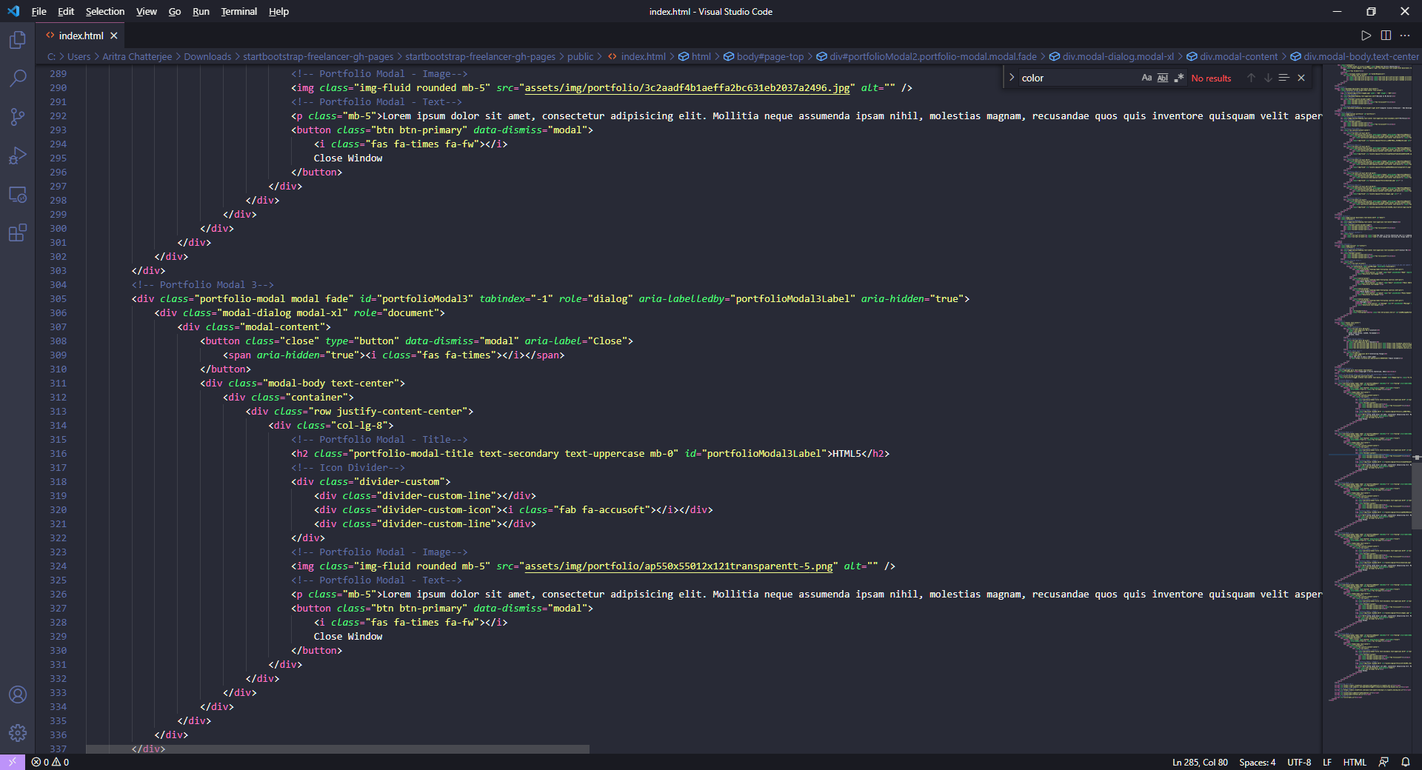

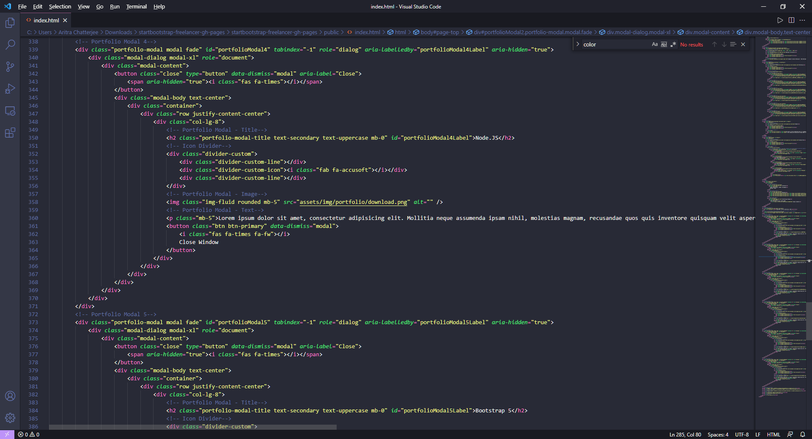

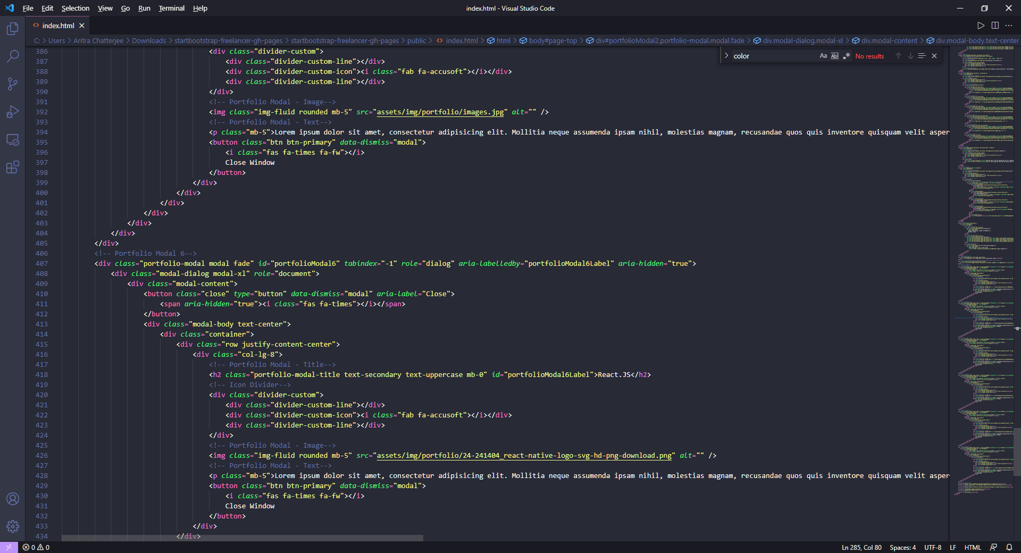

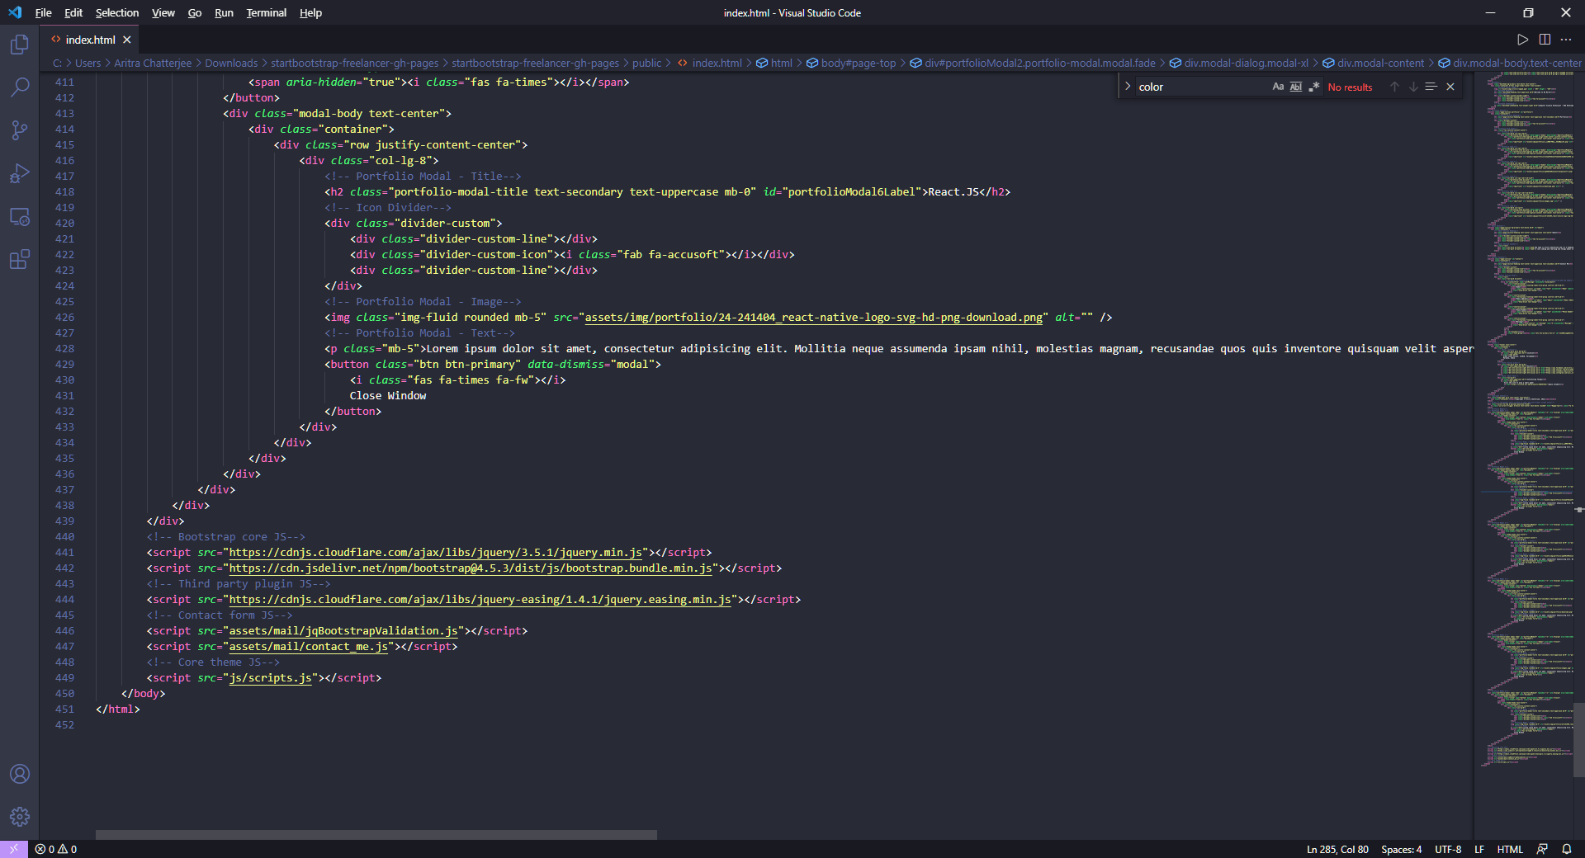

JavaScript Code:

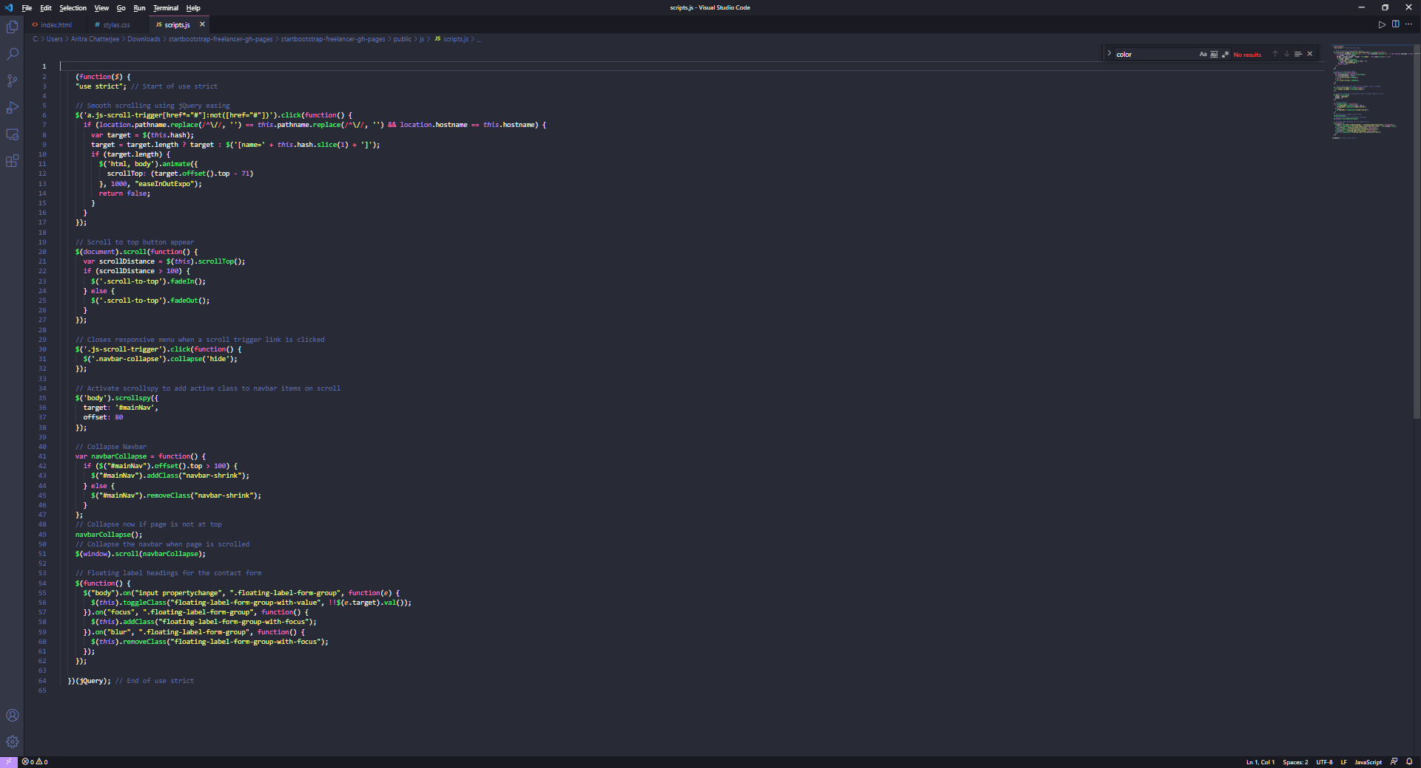

Node.js script:

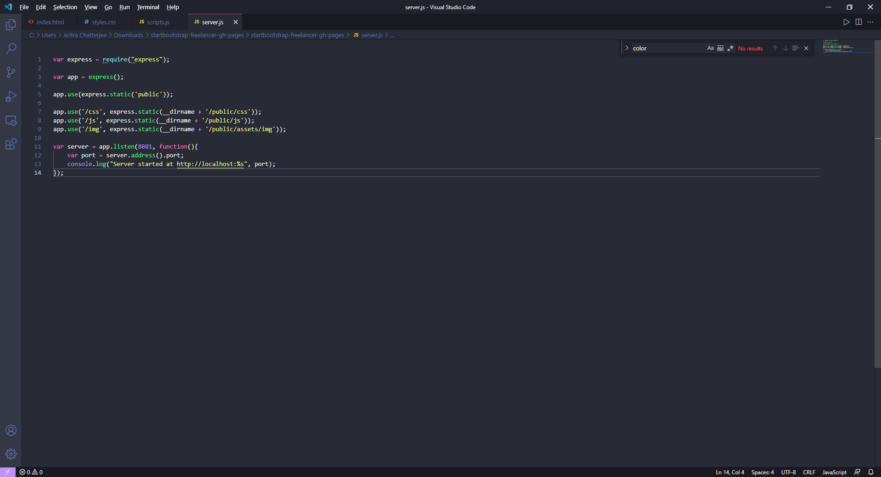

Execution:

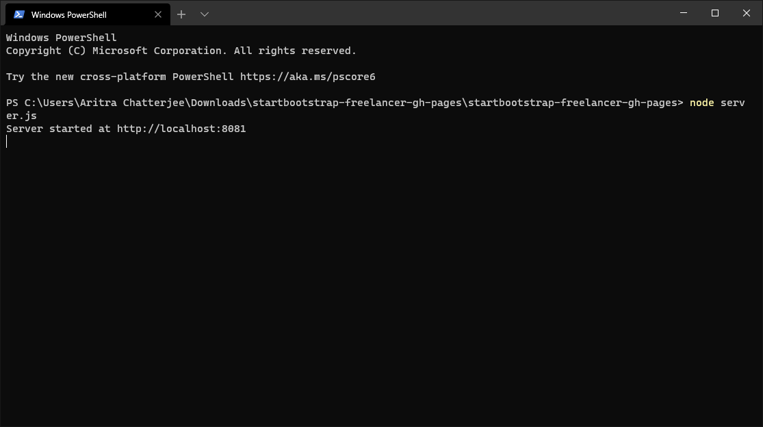

CSS code (included within zip file):